Set up these circuits and compare the brightness of the each lamp with lamp A.
Use the code B = brighter, D = dimmer, or S = same brightness.
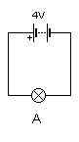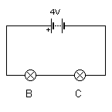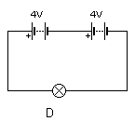
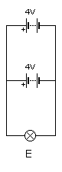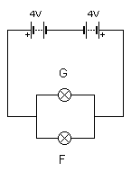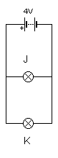
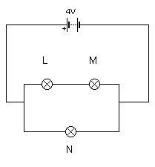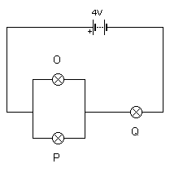
B = D | C = D | D = B | E = S | F = D
G = D | J = S | K = S | L = D
M = D | N = S | O = D | P = D | Q = D

